Name _________________________________

The Atom Review
Look over your NOTES and PRACTICE along with
completing this review to prepare for The Atom Assessment.
- How is each of the following calculated?

  - Mass number
  - Atomic number
  - Number of protons
  - Number of neutrons
  - Number of electrons

- Complete the following table:
Chemical  Symbol | # of protons | # of electrons | # of neutrons | Atomic # | Mass #
 | 12
 |  | 35 | 45
 |  |  |  | 11 | 23
₁₀₈
Ag
⁴⁷

- What is an isotope?

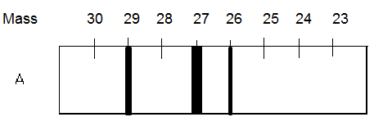
- Which isotope of element A is most abundant?

- Which isotope of element A deviated the least from its straight line

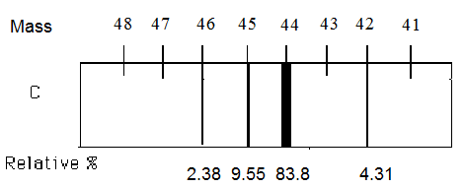
- Based on the spectrograph for element C, calculate the average atomic mass.

13.13 12.81 72.55 1.51

- What are the symbols, including superscripts and subscripts, of the isotopes of element C?

- Calculate the atomic mass of the element X and identify the element from the periodic table knowing that it has the following isotopes: ⁵⁴X (abundance 5.9%), ⁵⁶X (abundance 91.72%), ⁵⁷X (abundance 2.1%) and ⁵⁸X (abundance 0.28%).

Atomic Mass ________________ Element X is ________________________

Electrons in the atom
- Rank the following colors in order of decreasing energy: blue, green, red, yellow.

- Sketch two Bohr Diagrams: the first an atom with one e- in the ground state and the second an atom with one e- in an excited state.
Ground State Excited State

Explain what causes the atom to change state.

Describe what occurs as the atom returns to the ground state.

- Explain the following principles/rules IN YOUR OWN WORDS.

  - Heisenberg Uncertainty Principle:

  - Aufbau Principle:

  - Pauli Exclusion Principle:

  - Hund’s Rule:

- Complete the following table:
Energy Level | # of Sublevels | Sublevel names | # of Orbitals | Total # of e-
1
2
3

- Identify the elements with the following configurations:

  - 1s²2s²2p⁶3s²3p⁶4s²3d¹⁰4p⁶5s²4d³
  - 1s²2s²2p⁶3s¹
  - [Ne] 3s²3p³
  - [Xe]6s²

- Rank the following in order of increasing energy: 5s, 2s, 3p, 4s

- Complete orbital diagrams, write electron configurations, and determine the noble gas notation for the following elements:
Element | Orbital Diagrams | Electron Configuration | Noble Gas Notation
Br | 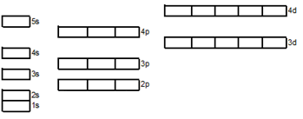
K

Cl

Fe

Ag

